Getting Started with Miro: A Step-by-Step Guide for Instructors
Miro is a digital whiteboard platform that allows you to collaborate with others in real-time, no matter where you are. It is a versatile tool that can be used for brainstorming, organizing ideas, project planning, and much more. This guide will provide step-by-step instructions for instructors on how to get started with Miro.

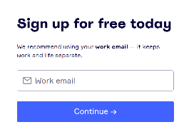
Step 1: Sign up for Miro

Go to the Miro website and sign up for a free account using your school email address.

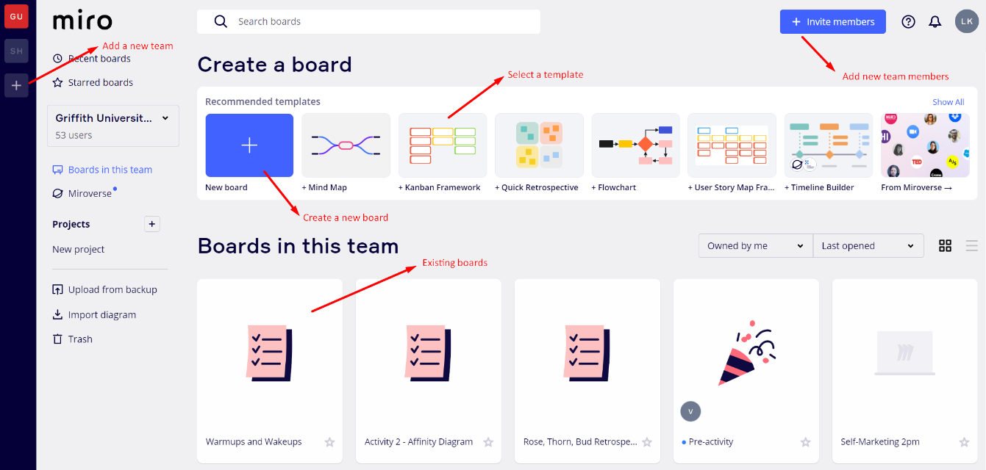
This is how Miro’s interface looks like:

Step 2: Create a new team

Once you have signed up, you can create a new team. Click on the "Create new team" button and give your team a name that reflects the subject or class you will be using Miro for. You can also add team members by entering their email addresses.
For example, if you are a science teacher, you might create a team called "Science Class" and invite all of your students to join.
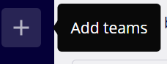
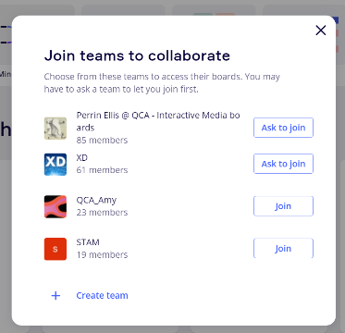

Step 3: Create a new board

Click on the "Create new board" button and choose a template or start from scratch. You can customize the board to fit your needs, such as by adding sections or columns.
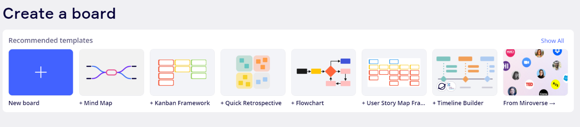
For example, if you are teaching a unit on the human body, you might create a board that includes sections for each of the body systems, such as the respiratory system, circulatory system, and digestive system.

Step 4: Assign tasks

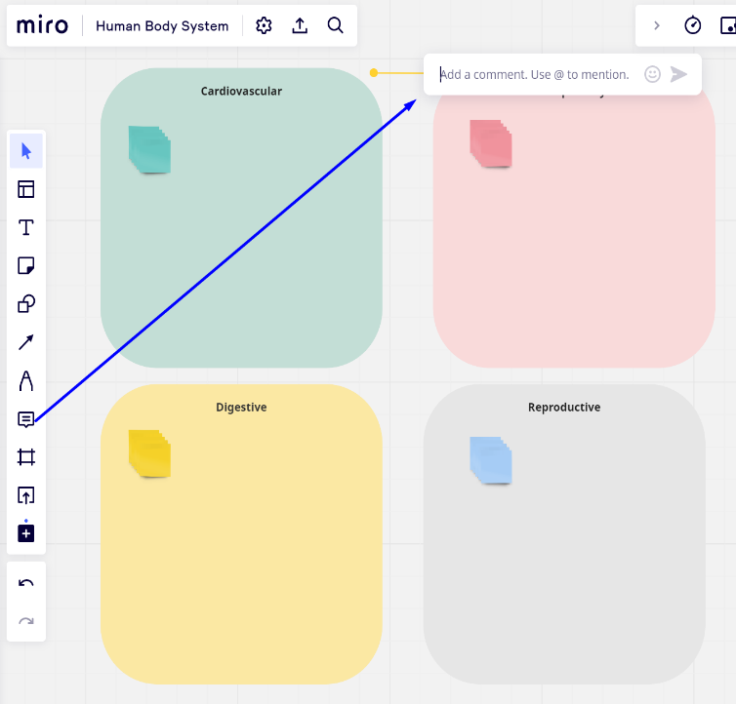
Once you have created your board, you can start assigning tasks to your students. For example, you might ask them to research a specific body system and add their findings to the appropriate section of the board.
To do this, you can create sticky notes or text boxes for each student and assign them to the appropriate section. You can also use the "@mention" feature to tag students in specific sections or comments.

Step 5: Provide feedback

As your students add content to the board, you can provide feedback on their work. You can leave comments or annotations on their contributions or use Miro's voting feature to gather feedback from the class.
For example, you might ask your students to vote on the most interesting fact they learned about the human body or the best diagram of a body system.

Step 6: Collaborate with other teachers
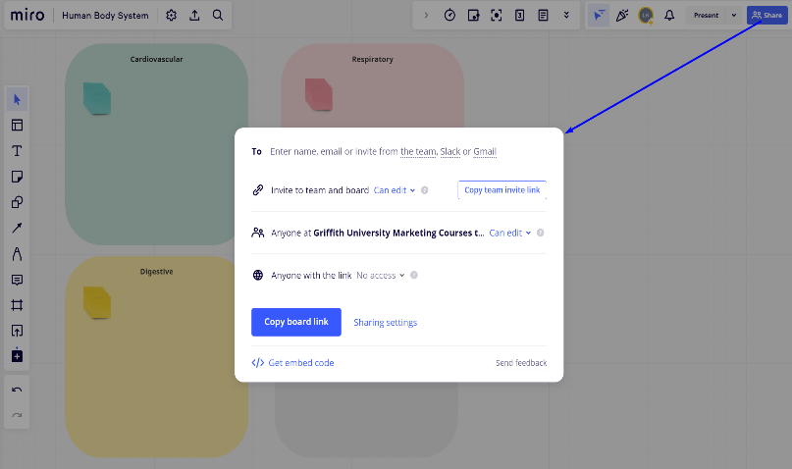
Finally, you can invite other teachers to your team and collaborate on lesson plans and other projects. This can be especially helpful if you are teaching a cross-curricular unit or working on a school-wide project.
For example, you might collaborate with a language arts teacher to create a board that combines science and writing, such as a board on the life cycle of a butterfly that includes a writing prompt for a creative story.

Overall, Miro is a versatile tool that can be used in a variety of ways to enhance teaching and learning. By following these simple instructions and getting creative with your board design and tasks, you can start using Miro to engage and collaborate with your students in new and exciting ways.

Privacy Settings in Miro
All boards are public. However, they can be made private on the Education, Business, Team, Enterprise, and Consultant plans. Once a user is granted access to a board, they will have access to all other boards within the same collaboration team.
It is important as instructors to consider unintended access to boards by students across different year levels and subjects. For staff members using Miro for moderation or marking purposes, it would be advisable to apply for an Educational license in advance.
These are two options you can use to ensure privacy:

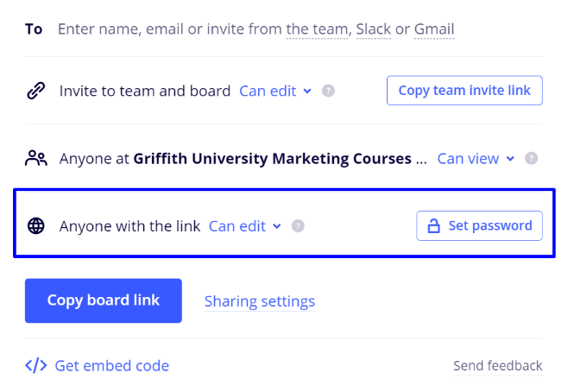
Option 1 – Setting a Password
You can enter a strong password (minimum of eight characters) if you enable access for Anyone with a link (Public access). The password will be automatically copied to your clipboard.
Once the password is set, all guest users must enter it to access the protected board. The password will remain valid for 72 hours, so users don't need to re-enter it during that time.

Option 2 – Modify the access rights of existing collaborators
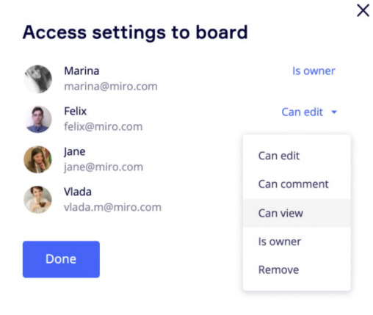
- Click on the Share button located in the top-right corner of the board.
- Select Manage Settings. This will show you a list of users who have access to the board. Note that the Manage Settings button will only appear if specific users were invited to the board via email, Gmail, or Slack.
- To adjust the access rights for a particular user, click on the drop-down list that indicates their current access level. You can also remove collaborators from the list. Additionally, the board owner can transfer ownership to another user.
- Confirm the changes by clicking Done.

